Owner Portal Bug List:

1. In homepage-Snapshot- When click month radio button and select any month page is getting loaded and it always shows only July month details.

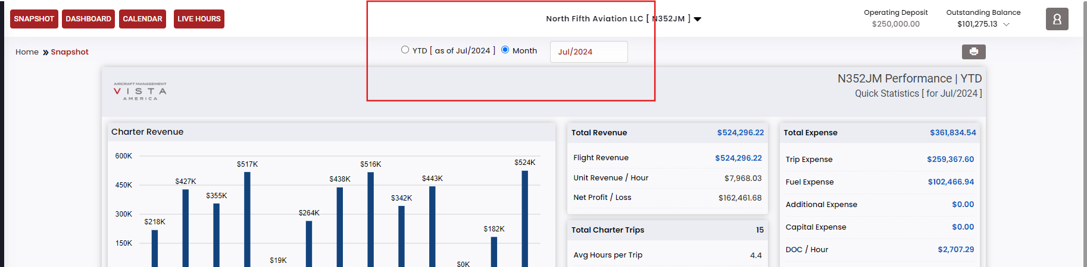

1. In Homepage-Dashboard- When click month radio button and select any month page is not getting loaded and previous details only displayed.

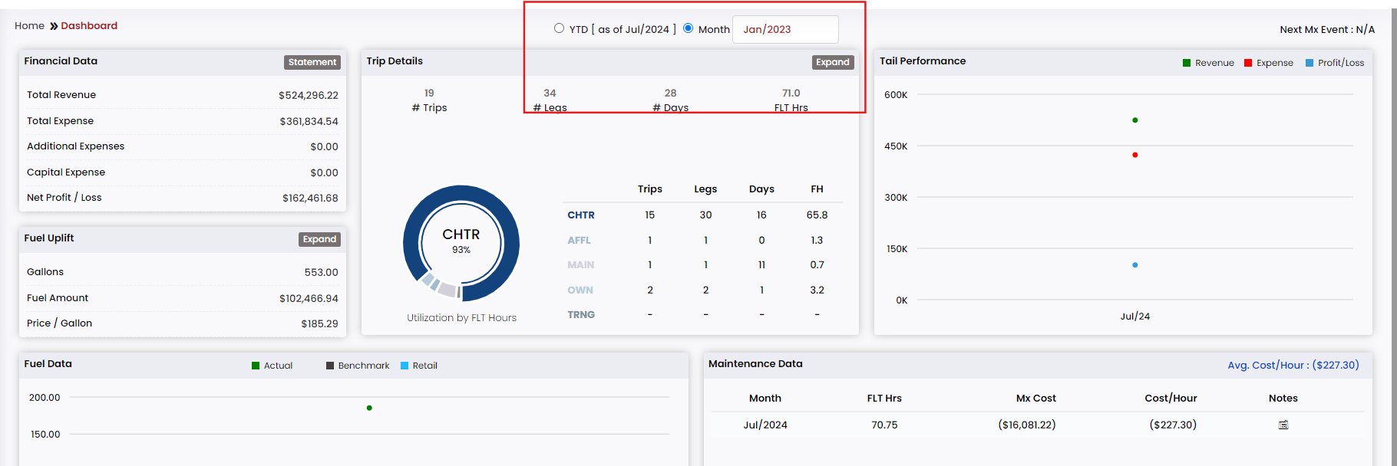

1. Excel functionality is not working in any page.
2. Management report-MS-Report-When select valid month and report type as rolling view and click view button, click monthly expenses tab, attachement button is not working in any tab.

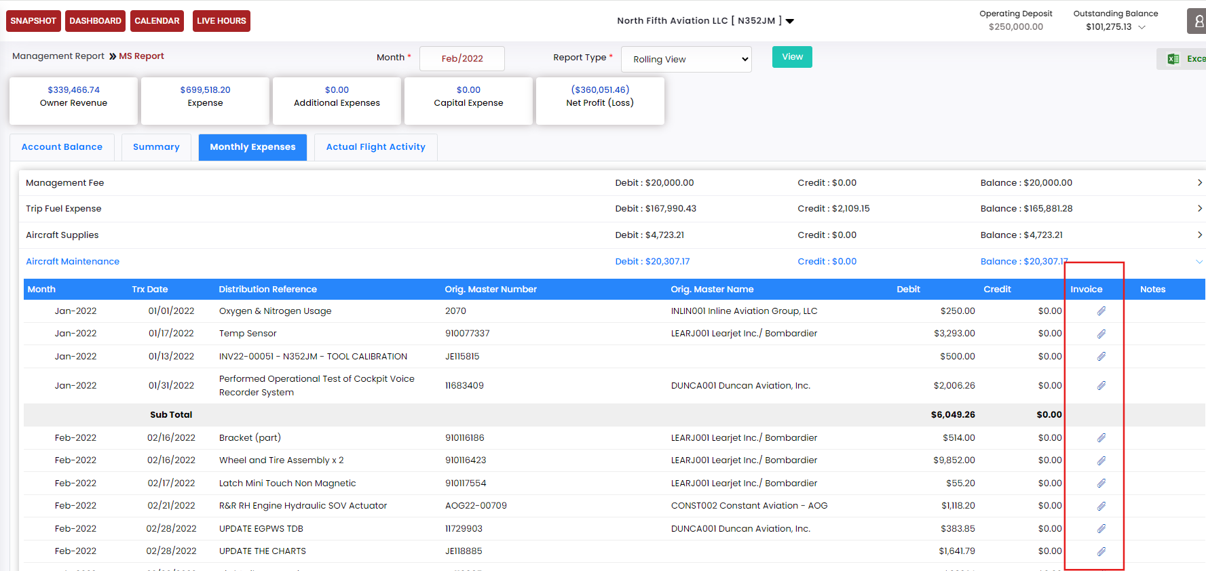

1. Management report-OSA View-Month tab is not working.

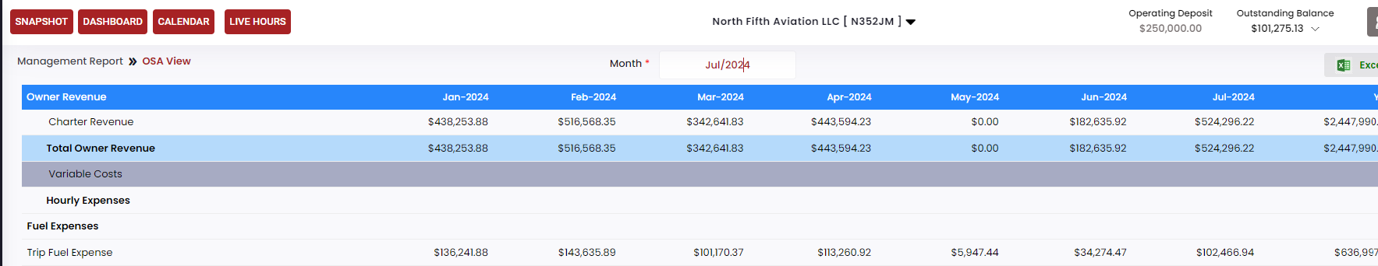

1. In reports-Owner trip expense-When enter into the page from and to calendar is empty, it need to show valid month details in both calendar tab.

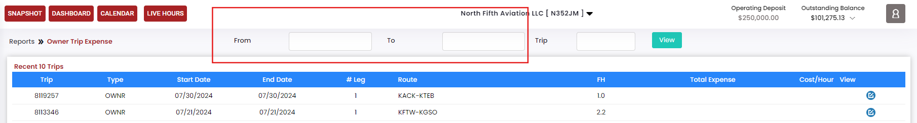

1. In reports- 380 Trip Expenses (beta)-When enter into the page from and to calendar is empty, it need to show valid month details in both calendar tab.

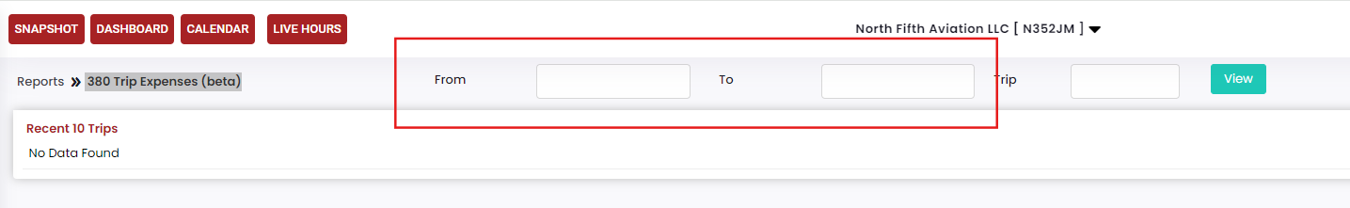

1. In reports- Charter Trip Expense-When enter into the page from and to calendar is empty, it need to show valid month details in both calendar tab.

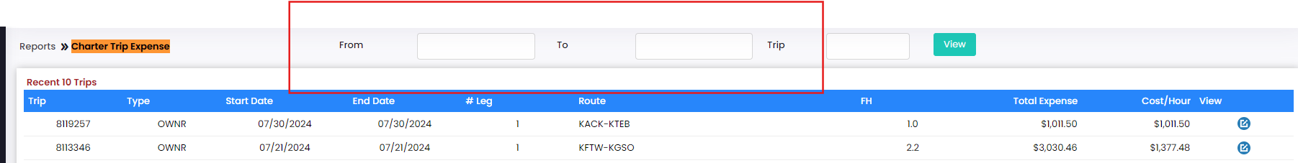

1. In reports- Charter Trip Expense-When select valid from and to date and click view button, details should not updated.

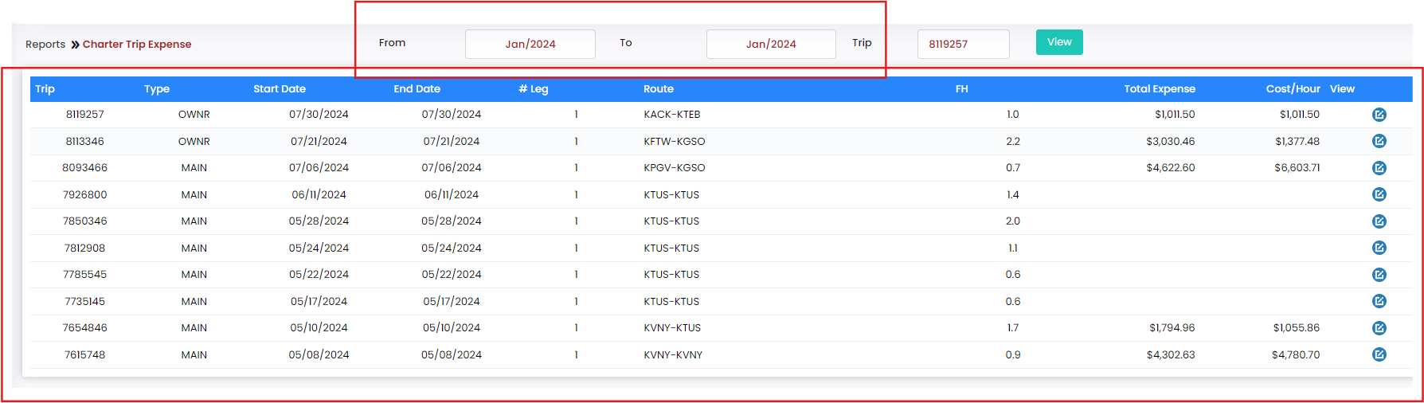

1. In reports- Charter Trip Expense-Edit button is not working and shows invalid error toast.

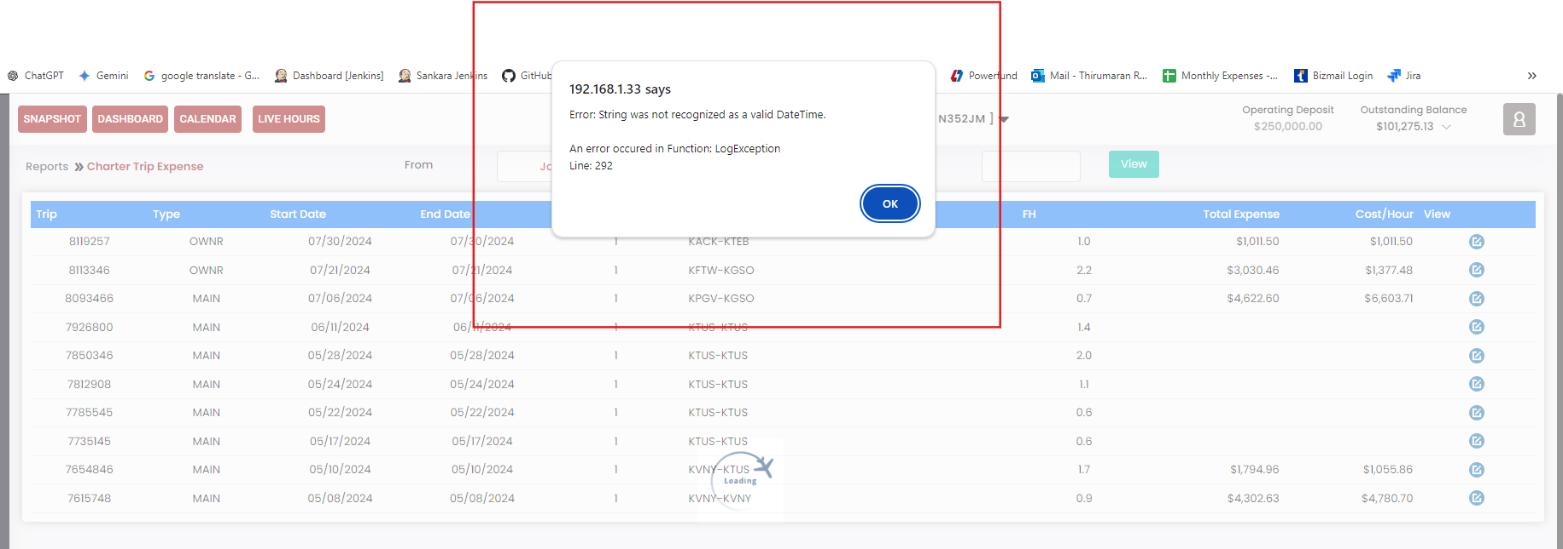

1. Reports-Fuel uplift-Edit button is not working and shows invalid error toast. It occurs when select from date as Jan/2024 and to date is july/2024.

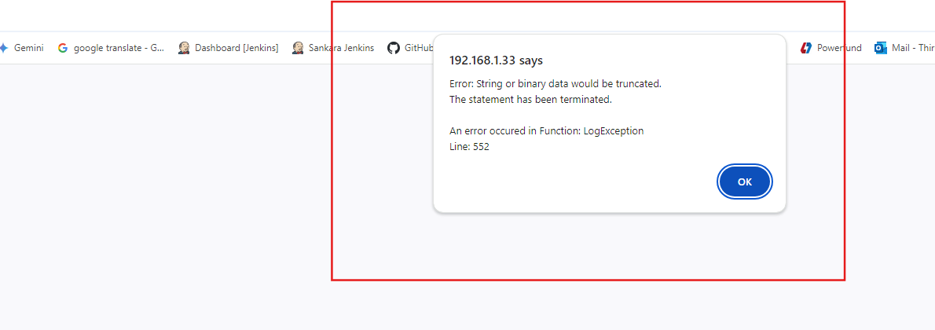

1. Reports-Fuel uplift-Select from date as Feb/2024 and to date is july/2024 and click edit button and again click view button it is not working and shows invalid error toast.

